FSTAB & SWAP Session Summary :

- Fstab (File system table) : It is a kind of file where we can write instructions for permanent mount of partitions.

- If we mount one of folder to the partition then that mount is not permanent. As soon as we shutdown the system it will unmount automatically.

- Fstab is one of way to do a permanent mount.

- /etc/fstab: file location
Syntax:
device_name/UUID mount_point format_type options(accessmode) disk_check disk_sync
For example,
- /dev/vgrise/lv2 /part2 ext4 defaults 0 0
- UUID="3914c381-9eaa-46ad-87c4-9158acb71456" /l1 ext4 defaults 0 0
After changing in file run “mount -a” command and then reboot the system
using the “reboot” or “init 6” command.

- Instead of device name we can used UUID ie. universal id. Because device name is system define that can be changeable therefore we can use id ie. unique

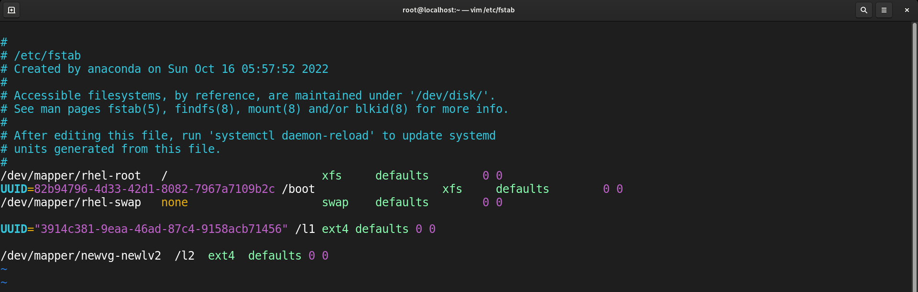

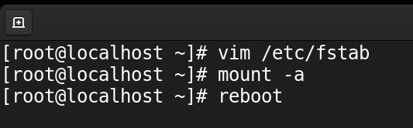

- Some of the commands:
- mount: return device name, format type, mount point, access mode
- mount -a: It will run after we change in /etc/fstab file. It will give an error if we write wrong syntax in that file otherwise it will not give any message/error.
- lsblk: return device name with partitions, mount point, etc.
- blkid: return partition name, uuid, format type, block size.

- Swap is a space on a disk that is used when the amount of physical RAM memory is full. When a Linux system runs out of RAM & If the system needs more memory resources then, inactive pages are moved from the RAM to the swap space. While swap space can help machines with a small amount of RAM, it should not be considered a replacement for more RAM.
- Data go to swap space from RAM ie. swapout
- Data come to the RAM from swap space ie. swapin

- Create a partition of any HD device and use that partition as swap space. & this kind of partition is known as swap partition.

- Step to swap space:
- Create a partition of any storage device.
- Convert that partition into a swap partition.
# mkswap [partition_name]
- Activate that space
# swapon [partition_name]
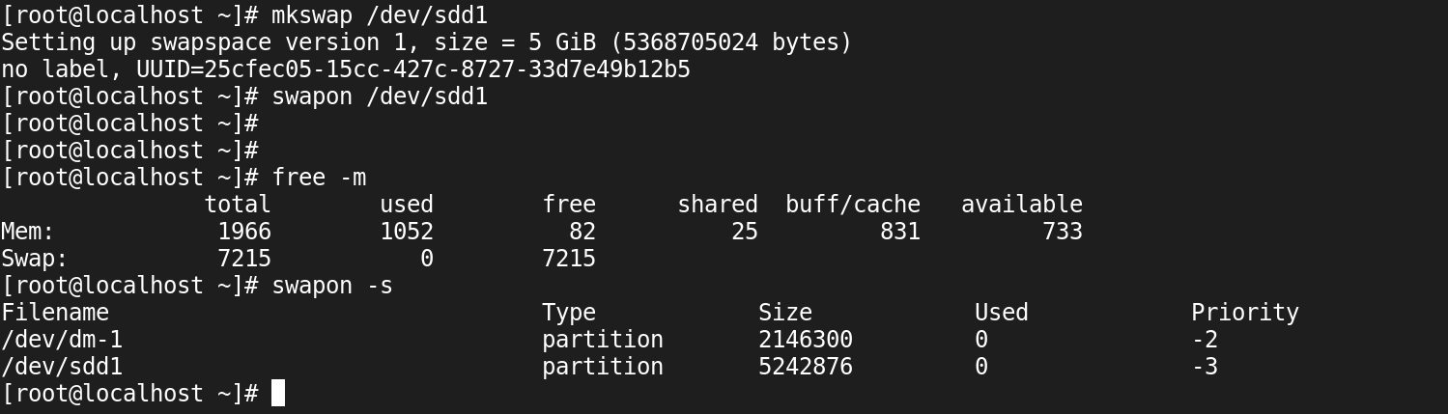

- To check RAM & Swap space:
# free -m
# swapon -s

- The CPU only reads the data from RAM. It can’t go to swap space.

